***EQUIFAX***

CMS Fusion

**QC tab**

**DOCUMENTATION**

Table of Contents

QC Tab 2

# QC Tab

Review project and verify each process. User can approve or reject process. If project have more than one fulfillment analysist then they can verify each other.

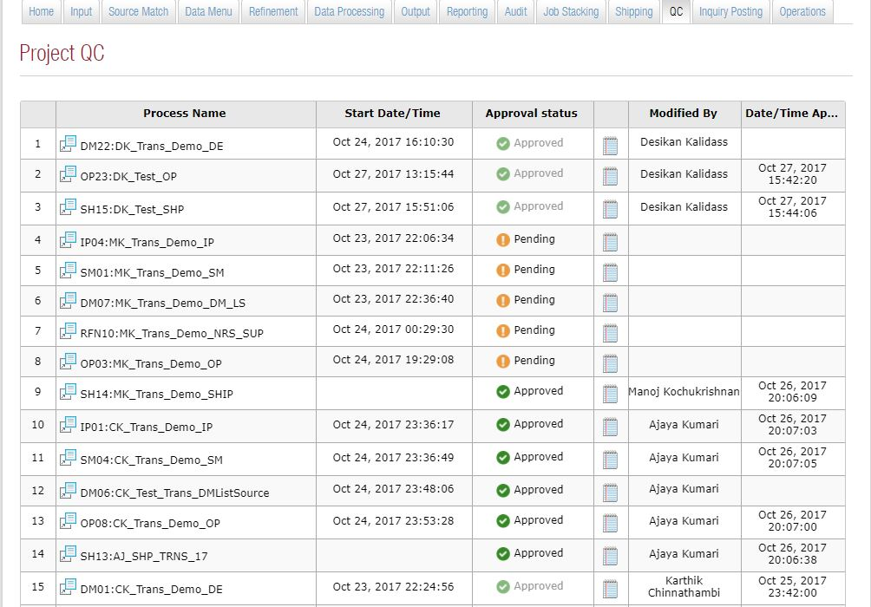

## View project QC Status

While clicking on the QC tab, it will list the set of processes ready for QC

* Process name
* Start date / Time.
* Approval status
* Remarks
* Modified By
* Date / Time Approved

User can view and verify each processes configuration and result

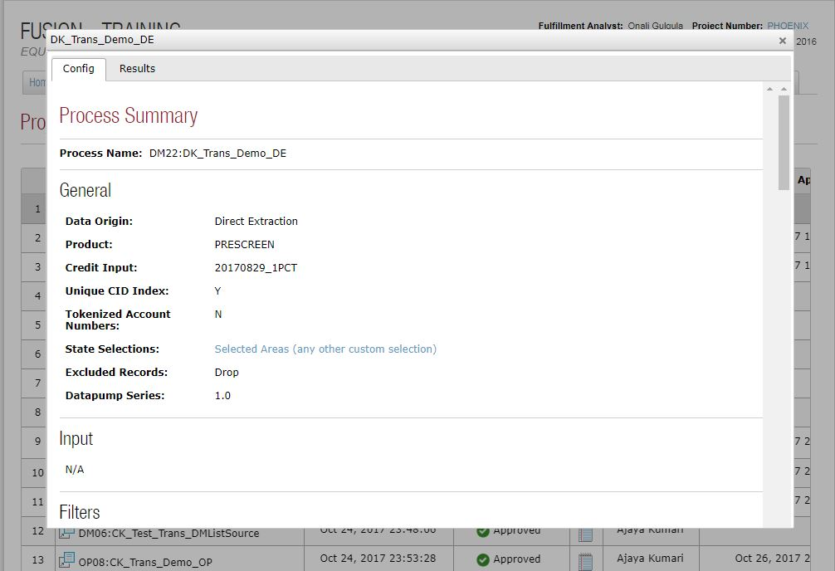

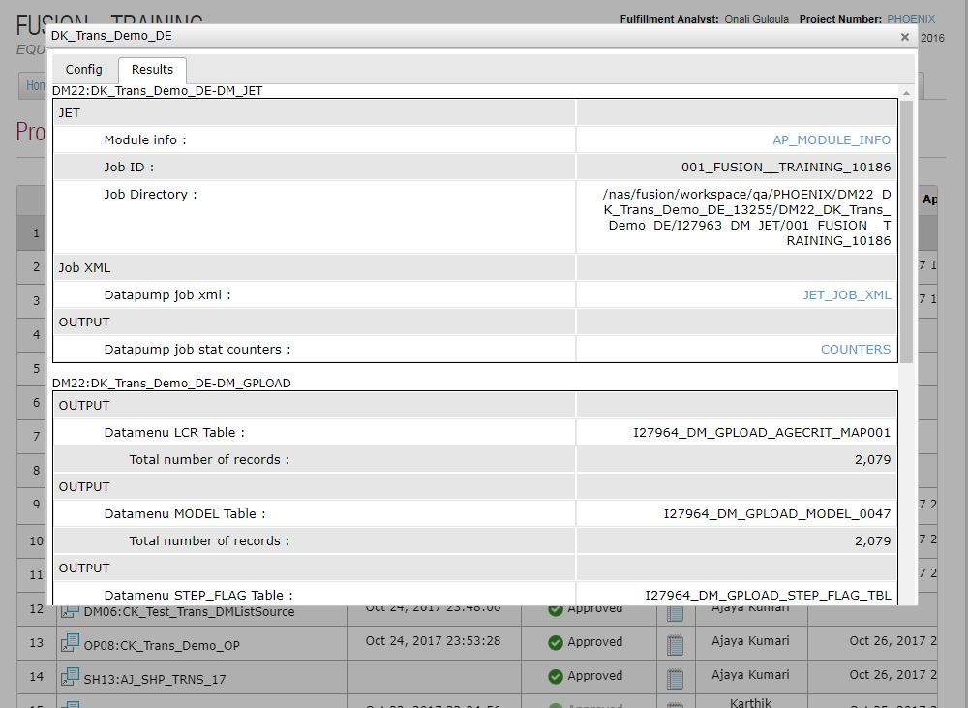

Before submitting shipping process all the related jobs/ process must be passed through QC process. Each artifacts and data will validated through summary, after verification user can approve or reject particular process. User can enter remark against a process. If particular process rejected then fulfillment analysist can rerun with corrected configuration.